National Gateway Infrastructure (NGI)

Interface Design Document
NGI Report Traffic Contraventions Service

Document Control
Amendment History:
S. No. | Authors (s) | Version | Date | Change Description
1. | Sudhakar M | 1.0 | 28-10-2019 | Initial Draft.

Reviewers:
S. No. | Name | Position | Version
 | Thiyaneshwaran R | Technical Lead | 1.0

Table of Contents
1. Definition, Acronyms and Abbreviations 4
2. Service Properties 4
2.1 Business Properties 4
2.2 Operations & Properties 4
2.3 Technical Properties 5
2.3.1 RetrieveCameraLocations 5
2.4 Business Flow Usage 6
2.5 Message Definition 6
2.6 Error Code and Error Message 6

Definition, Acronyms and Abbreviations
IGA | Information & eGovernment Authority
NGI | National Gateway Infrastructure
CIO | Central Informatics Organization
B2B | Business To Business
GDT | General Directorate of Traffic

Service Properties

Business Properties
Service | Service ID/Code | Description | Status | Associations
 |  |  |  | Function/ process | Goal
NGI_ReportTrafficContraventions | NGI_ReportTrafficContraventions | - LKUPGovernorate  - LKUPArea  - LKUPContraventionList  - LKUPCountryList  - LKUPPlateColor  - LKUPVehicleMake  - LKUPVehicleModels  - LKUPVehicleColor  - UploadAttachment  - SubmitTrafficContravention | -- | This service is exposed on NGI layer. | -

Operations & Properties
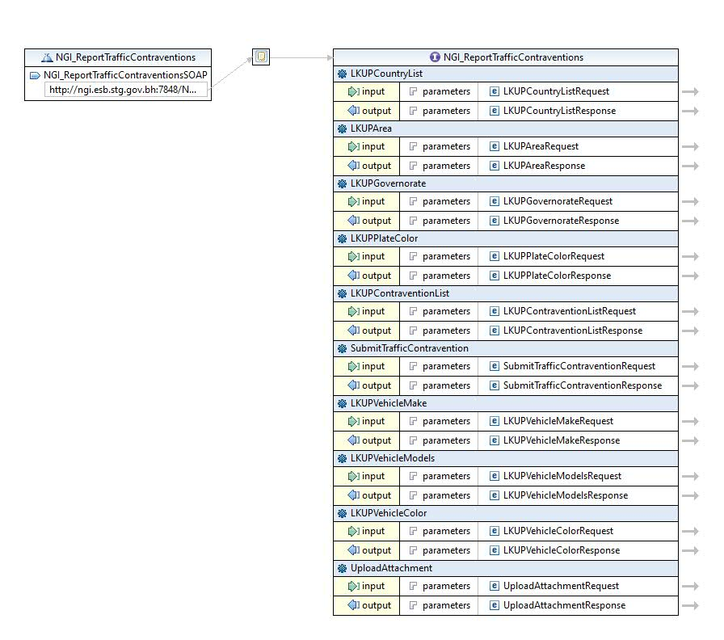

Technical Properties

LKUPGovernorate
Service Id | NGI_ReportTrafficContraventions
Operation Id | LKUPGovernorate
Operation | LKUPGovernorate
Input Msg | 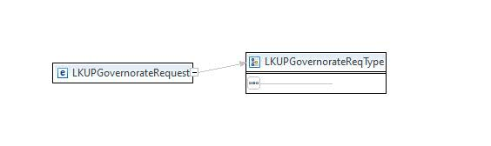
Output Msg | 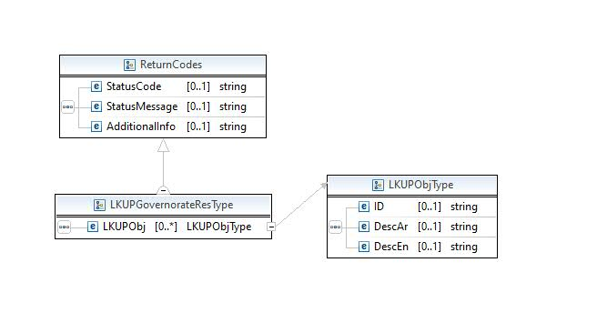
Exception (Fault) | Default SOAP/ SOAP12 fault message will be generated

LKUPArea
Service Id | NGI_ReportTrafficContraventions
Operation Id | LKUPArea
Operation | LKUPArea
Input Msg | 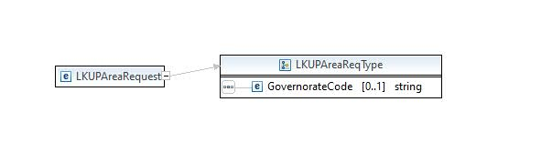
Output Msg | 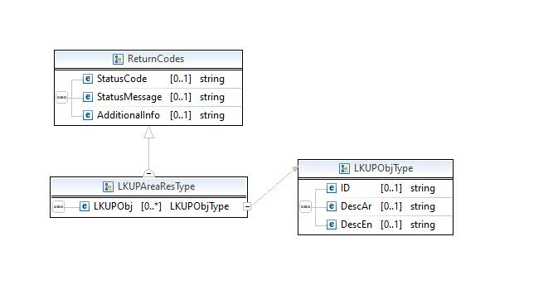
Exception (Fault) | Default SOAP/ SOAP12 fault message will be generated

LKUPContraventionList
Service Id | NGI_ReportTrafficContraventions
Operation Id | LKUPContraventionList
Operation | LKUPContraventionList
Input Msg | 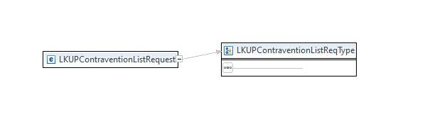
Output Msg | 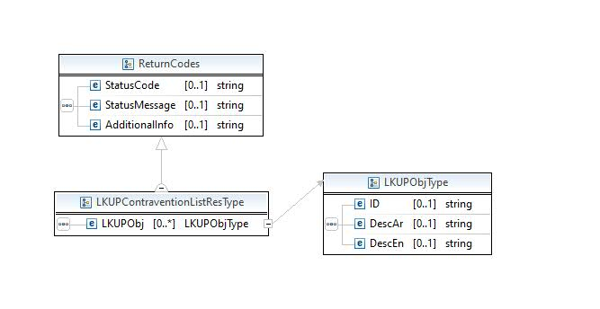
Exception (Fault) | Default SOAP/ SOAP12 fault message will be generated

LKUPCountryList
Service Id | NGI_ReportTrafficContraventions
Operation Id | LKUPCountryList
Operation | LKUPCountryList
Input Msg | 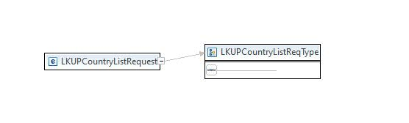
Output Msg | 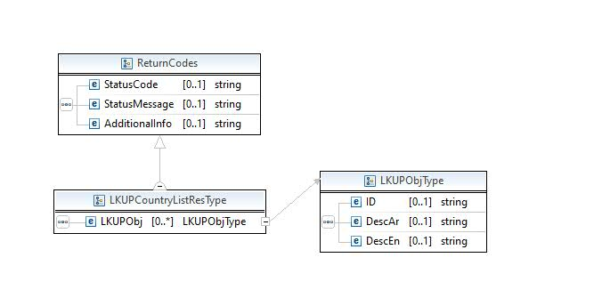
Exception (Fault) | Default SOAP/ SOAP12 fault message will be generated

LKUPPlateColor
Service Id | NGI_ReportTrafficContraventions
Operation Id | LKUPPlateColor
Operation | LKUPPlateColor
Input Msg | 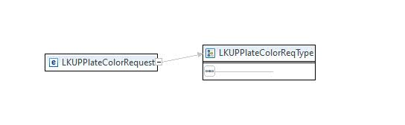
Output Msg | 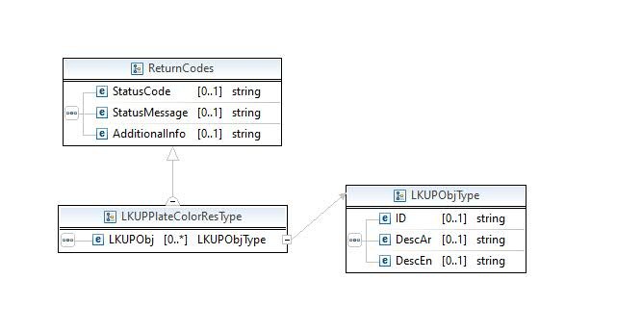
Exception (Fault) | Default SOAP/ SOAP12 fault message will be generated

LKUPVehicleMake
Service Id | NGI_ReportTrafficContraventions
Operation Id | LKUPVehicleMake
Operation | LKUPVehicleMake
Input Msg | 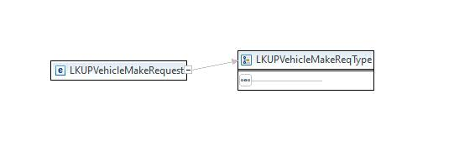
Output Msg | 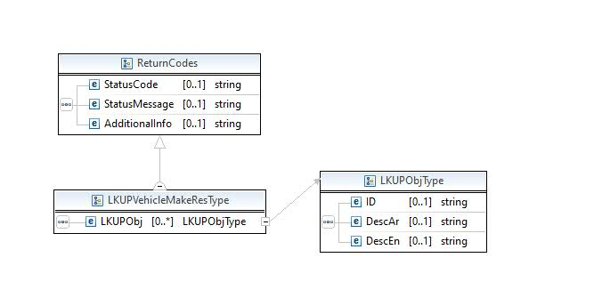
Exception (Fault) | Default SOAP/ SOAP12 fault message will be generated

LKUPVehicleModels
Service Id | NGI_ReportTrafficContraventions
Operation Id | LKUPVehicleModels
Operation | LKUPVehicleModels
Input Msg | 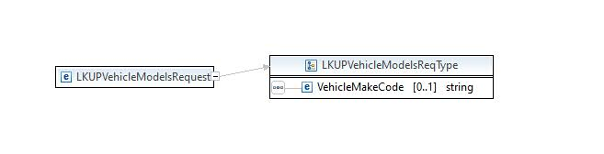
Output Msg | 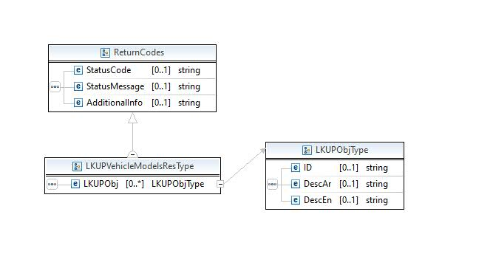
Exception (Fault) | Default SOAP/ SOAP12 fault message will be generated

LKUPVehicleColor
Service Id | NGI_ReportTrafficContraventions
Operation Id | LKUPVehicleColor
Operation | LKUPVehicleColor
Input Msg | 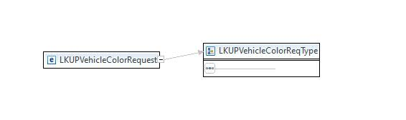
Output Msg | 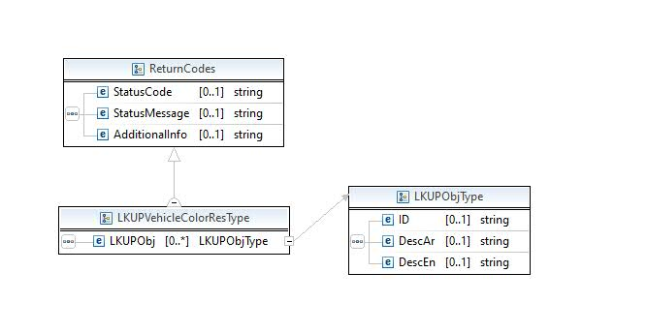
Exception (Fault) | Default SOAP/ SOAP12 fault message will be generated

UploadAttachment
Service Id | NGI_ReportTrafficContraventions
Operation Id | UploadAttachment
Operation | UploadAttachment
Input Msg | 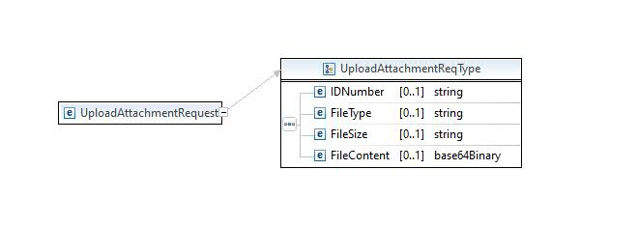
Output Msg | 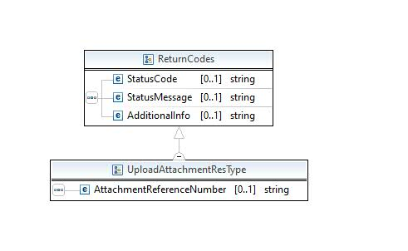
Exception (Fault) | Default SOAP/ SOAP12 fault message will be generated

SubmitTrafficContravention
Service Id | NGI_ReportTrafficContraventions
Operation Id | SubmitTrafficContravention
Operation | SubmitTrafficContravention
Input Msg | 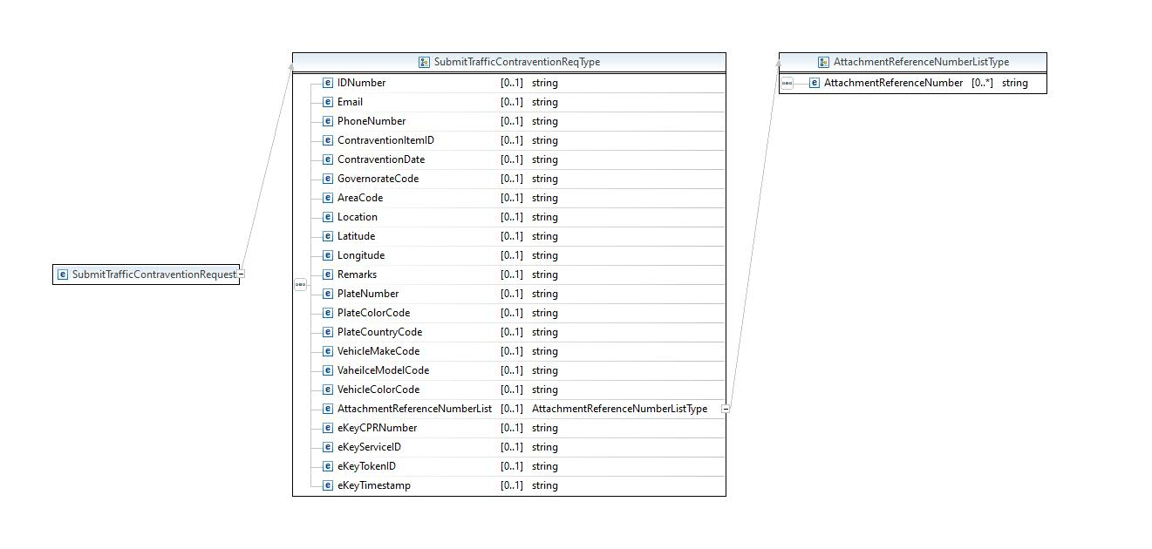
Output Msg | 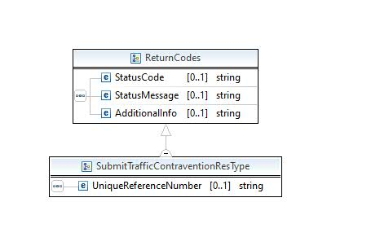
Exception (Fault) | Default SOAP/ SOAP12 fault message will be generated
NGI Comments | - ContraventionDate – Date format is: yyyyMMddHHmmss

Business Flow Usage
NA

Message Definition

Find the WSDL file below.

Error Code and Error Message
Find the below Status Codes and Status Messages
GDT Error Codes | GDT Error Messages | NGI STATUS CODE | NGI STATUS MESSAGES | NGI Method
RTV-000 | Success. | GDTCL-0000 | SUCCESS | Generic for All Operations
 |  | GDTRTC-0001 | FAILURE, EXCEPTION INVOKING BACKEND | Generic for All Operations
RTV-001 | Failure, no records fetched. | GDTRTC-0004 | FAILURE, NO RECORDS FOUND | Generic for All Operations LKUPVehicleModels
 |  | GDTRTC-0005 | FAILURE, UNCHECKED EXCEPTION | Generic for All Operations
RTV-002 | Failure, Operation could not be completed successfully. | GDTRTC-0011 | Failure, Operation could not be completed successfully. | SubmitTrafficContravention
RTV-003 | Mandatory field - Reporting Contravention Details DTO is missing. | GDTRTC-0012 | Mandatory field - Reporting Contravention Details DTO is missing. | SubmitTrafficContravention
RTV-004 | Mandatory field - Reporter ID Number is missing. | GDTRTC-0013 | Mandatory field - Reporter ID Number is missing. | SubmitTrafficContravention
RTV-005 | Invalid Reporter ID Number. | GDTRTC-0014 | Invalid Reporter ID Number. | SubmitTrafficContravention
RTV-006 | Mandatory field - Reporter Phone Number is missing. | GDTRTC-0015 | Mandatory field - Reporter Phone Number is missing. | SubmitTrafficContravention
RTV-007 | Mandatory field - Reporter Email Address is missing. | GDTRTC-0016 | Mandatory field - Reporter Email Address is missing. | SubmitTrafficContravention
RTV-008 | Invalid Reporter Email Address. | GDTRTC-0017 | Invalid Reporter Email Address. | SubmitTrafficContravention
RTV-009 | Mandatory field - Contravention Item Type Code is missing. | GDTRTC-0018 | Mandatory field - Contravention Item Type Code is missing. | SubmitTrafficContravention
RTV-010 | Invalid field - Passed Contravention Item Type Code not supported. | GDTRTC-0019 | Invalid field - Passed Contravention Item Type Code not supported. | SubmitTrafficContravention
RTV-011 | Invalid Contravention Item Type Code. | GDTRTC-0020 | Invalid Contravention Item Type Code. | SubmitTrafficContravention
RTV-012 | Mandatory field - Contravention Date is missing. | GDTRTC-0021 | Mandatory field - Contravention Date is missing. | SubmitTrafficContravention
RTV-013 | Invalid Contravention Date. | GDTRTC-0022 | Invalid Contravention Date. | SubmitTrafficContravention
RTV-014 | Invalid - Contravention Date cannot be in future. | GDTRTC-0023 | Invalid - Contravention Date cannot be in future. | SubmitTrafficContravention
RTV-015 | Mandatory field - Governorate Code is missing. | GDTRTC-0024 | Mandatory field - Governorate Code is missing. | SubmitTrafficContravention
RTV-016 | Invalid Governorate Code. | GDTRTC-0025 | Invalid Governorate Code. | SubmitTrafficContravention
RTV-017 | Mandatory field - Area Code is missing. | GDTRTC-0026 | Mandatory field - Area Code is missing. | SubmitTrafficContravention
RTV-018 | Invalid Area Code. | GDTRTC-0027 | Invalid Area Code. | SubmitTrafficContravention
RTV-019 | Mandatory field - Road is missing. | GDTRTC-0028 | Mandatory field - Road is missing. | SubmitTrafficContravention
RTV-020 | Mandatory field - Location Latitude is missing. | GDTRTC-0029 | Mandatory field - Location Latitude is missing. | SubmitTrafficContravention
RTV-021 | Mandatory field - Location Longitude is missing. | GDTRTC-0030 | Mandatory field - Location Longitude is missing. | SubmitTrafficContravention
RTV-022 | Invalid Location Latitude. | GDTRTC-0031 | Invalid Location Latitude. | SubmitTrafficContravention
RTV-023 | Invalid Location Longitude. | GDTRTC-0032 | Invalid Location Longitude. | SubmitTrafficContravention
RTV-024 | Invalid Plate Number. | GDTRTC-0033 | Invalid Plate Number. | SubmitTrafficContravention
RTV-025 | Mandatory field - Plate number is missing. | GDTRTC-0034 | Mandatory field - Plate number is missing. | SubmitTrafficContravention
RTV-026 | Invalid Plate Color. | GDTRTC-0035 | Invalid Plate Color. | SubmitTrafficContravention
RTV-027 | Mandatory field - Plate Color is missing. | GDTRTC-0036 | Mandatory field - Plate Color is missing. | SubmitTrafficContravention
RTV-028 | Invalid Plate Country Code. | GDTRTC-0037 | Invalid Plate Country Code. | SubmitTrafficContravention
RTV-029 | Mandatory field - Plate Country Code is missing. | GDTRTC-0038 | Mandatory field - Plate Country Code is missing. | SubmitTrafficContravention
RTV-030 | Mandatory field - Vehicle Color is missing. | GDTRTC-0039 | Mandatory field - Vehicle Color is missing. | SubmitTrafficContravention
RTV-031 | Mandatory field - Vehicle Make is missing. | GDTRTC-0040 | Mandatory field - Vehicle Make is missing. | SubmitTrafficContravention
RTV-032 | Mandatory field - Vehicle Model is missing. | GDTRTC-0041 | Mandatory field - Vehicle Model is missing. | SubmitTrafficContravention
RTV-033 | Invalid Vehicle Color. | GDTRTC-0042 | Invalid Vehicle Color. | SubmitTrafficContravention
RTV-034 | Invalid Vehicle Make. | GDTRTC-0043 | Invalid Vehicle Make. | SubmitTrafficContravention
RTV-035 | Invalid Vehicle Model. | GDTRTC-0044 | Invalid Vehicle Model. | SubmitTrafficContravention
RTV-036 | No Attachment Document Details. | GDTRTC-0045 | No Attachment Document Details. | UploadAttachment
RTV-037 | Mandatory field - Attachment Document File Type is missing. | GDTRTC-0046 | Mandatory field - Attachment Document File Type is missing. | UploadAttachment
RTV-038 | Mandatory field - Attachment Document File Size is missing. | GDTRTC-0047 | Mandatory field - Attachment Document File Size is missing. | UploadAttachment
RTV-039 | Mandatory field - Attachment Document File Content is missing. | GDTRTC-0048 | Mandatory field - Attachment Document File Content is missing. | UploadAttachment
RTV-040 | Attachment Document size is too big. Max size: 2048KB (2MB). | GDTRTC-0049 | Attachment Document size is too big. Max size: 2048KB (2MB). | UploadAttachment
RTV-041 | Invalid Attachment Document File Type. Only JPG, JPEG, PNG, and BMP is accepted. | GDTRTC-0050 | Invalid Attachment Document File Type. Only JPG, JPEG, PNG, and BMP is accepted. | UploadAttachment

Security

Standard WS security features will be used to secure the service. Please use the below security headers based on the end point either SOAP1.1 or SOAP1.2

Sample SOAP1.1 Header
<soapenv:Header>
<wsse:Security soapenv:actor="ngi" mustUnderstand="1" xmlns:wsse="http://docs.oasis-open.org/wss/2004/01/oasis-200401-wss-wssecurity-secext-1.0.xsd">
<wsse:UsernameToken>
<wsse:Username wsu:Id="unt_907818524" xmlns:wsu="http://docs.oasis-open.org/wss/2004/01/oasis-200401-wss-wssecurity-utility-1.0.xsd">username</wsse:Username>
<wsse:Password Type="http://docs.oasis-open.org/wss/2004/01/oasis-200401-wss-username-token-profile-1.0#PasswordText">password</wsse:Password>
</wsse:UsernameToken>
</wsse:Security>
</soapenv:Header>

